Launching the new ‘Abbots’ Way’ Pilgrimage –
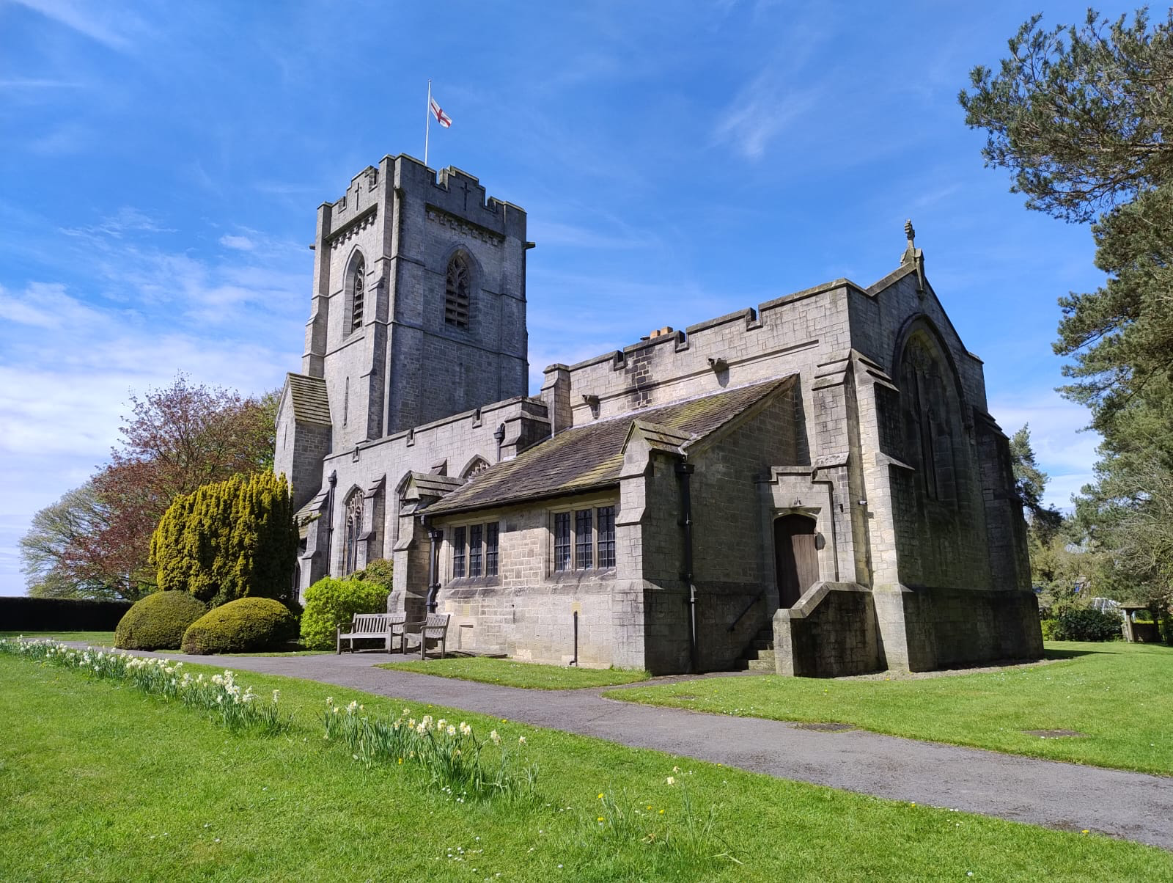Winksley

Winksley

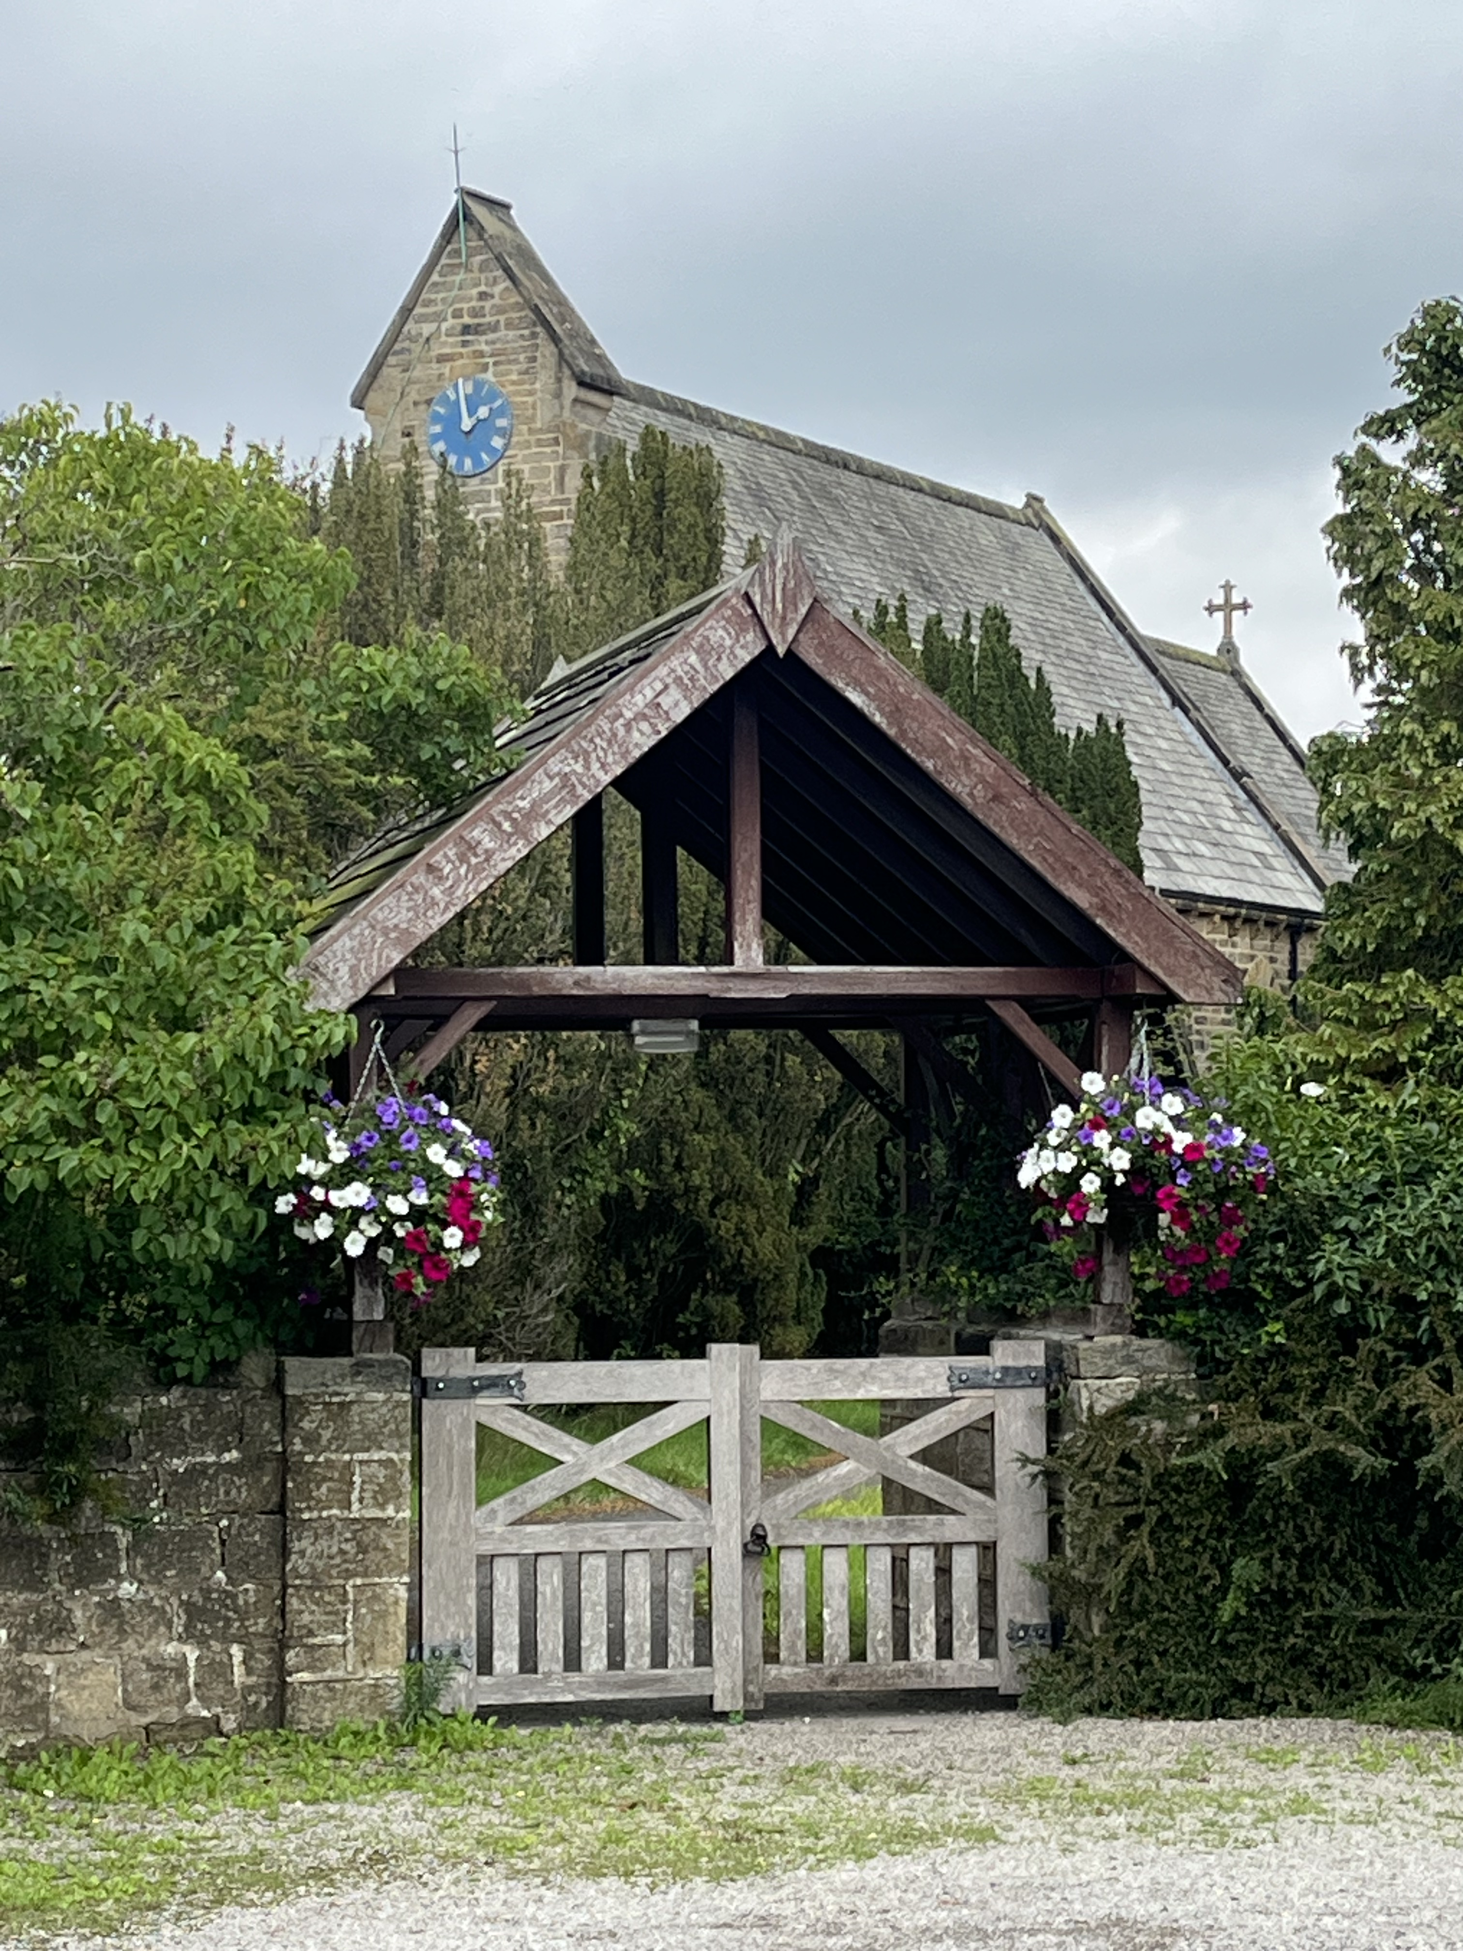Sawley
the first of our three
‘Fountains Ways – Ancient Paths for Modern Pilgrims’

After months of planning, the ‘soft launch’ of the new ‘Abbots’ Way’ will take place on Saturday 13th September, coinciding with the annual Yorkshire Churches Day. It is hoped that many folk from across North Yorkshire will join us for this special day!
Following a Lent study series on Pilgrimage and subsequent Pilgrimage from Winksley to Fountains Abbey, in 2024, ‘Abbots’ Way’ aims to get people out walking in this glorious Nidderdale area, visiting four beautiful rural churches located in the Fountains Benefice - including William Burges’ famous St Mary’s, Studley Royal, by Fountains Abbey – and enjoying good local hospitality.
Recognising the growing interest in Pilgrimage nationally and internationally, the ‘Fountains Ways’ project group are working on a series of three interlocking Pilgrimages, of which this is the first. These will be formally launched, with the support of North Yorkshire County Council, particularly its NY Tourism team, by Easter 2026.
In addition to OS Map-bearing descriptive leaflets, church welcome boards will help the pilgrims both to view the buildings and engage with church community life. Church ‘stamps’ – like those used on the various Caminos – will, in time, be available to stamp pilgrim ‘passports’, and children’s quizzes etc will offer young people a way of participating, also. In time, and with NY Tourism support, the relevant information will be web-based, accessed via QR codes.
Tom Ramsden, Churchwarden of St John’s Church, Mickley, Chair of YHCT, and co-leader of the group, commented, ‘This is a wonderful opportunity to enjoy the churches, the heritage and the landscape of beautiful Nidderdale’.
So, on Saturday 13th September, YC Day, a group of us will meet at Sawley, nr Ripon, at 10.30am (parking on the village green), to start an accompanied walk, and taking packed lunches. The first stop will be just nearby, at St Michael and All Angels, Sawley. The second church stop is St Mary’s, Studley Royal (open 11.30am-3.30pm). En route, we may wish to make use of the facilities or purchase refreshments from the Fountains Abbey Visitors’ Centre. From there, we’ll head towards St Cuthbert and St Oswald, Winksley, a beautiful early 20th Century ‘Arts and Crafts’ building (open from 1pm onwards). Additional toilet facilities will be available nearby. The fourth church visit is to St Lawrence, Aldfield, a fine 18th Century building with box pews and triple-decker pulpit, largely untouched since its construction. The final leg of the Pilgrimage will take us back across the River Skell, and up to Sawley. The whole route is about 9 miles which we estimate will take about 6 hours, including breaks, walking at a gentle pace. There may be an option of losing a section, for those seeking something slightly shorter. The going is moderate, and there are a number of stiles to cross. Stout footwear is recommended, and waterproofs, in case of rain. The ‘draw’ at the end is The Sawley Arms, a much-appreciated local pub, with a cosy interior and decent exterior seating.
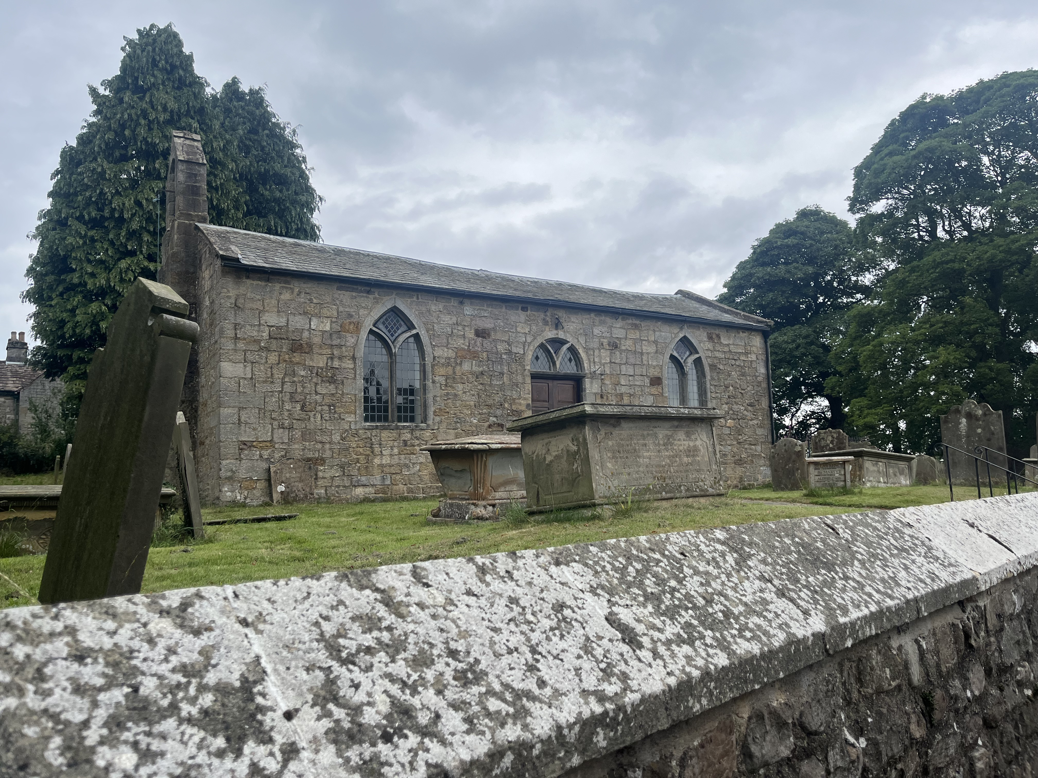Aldfield
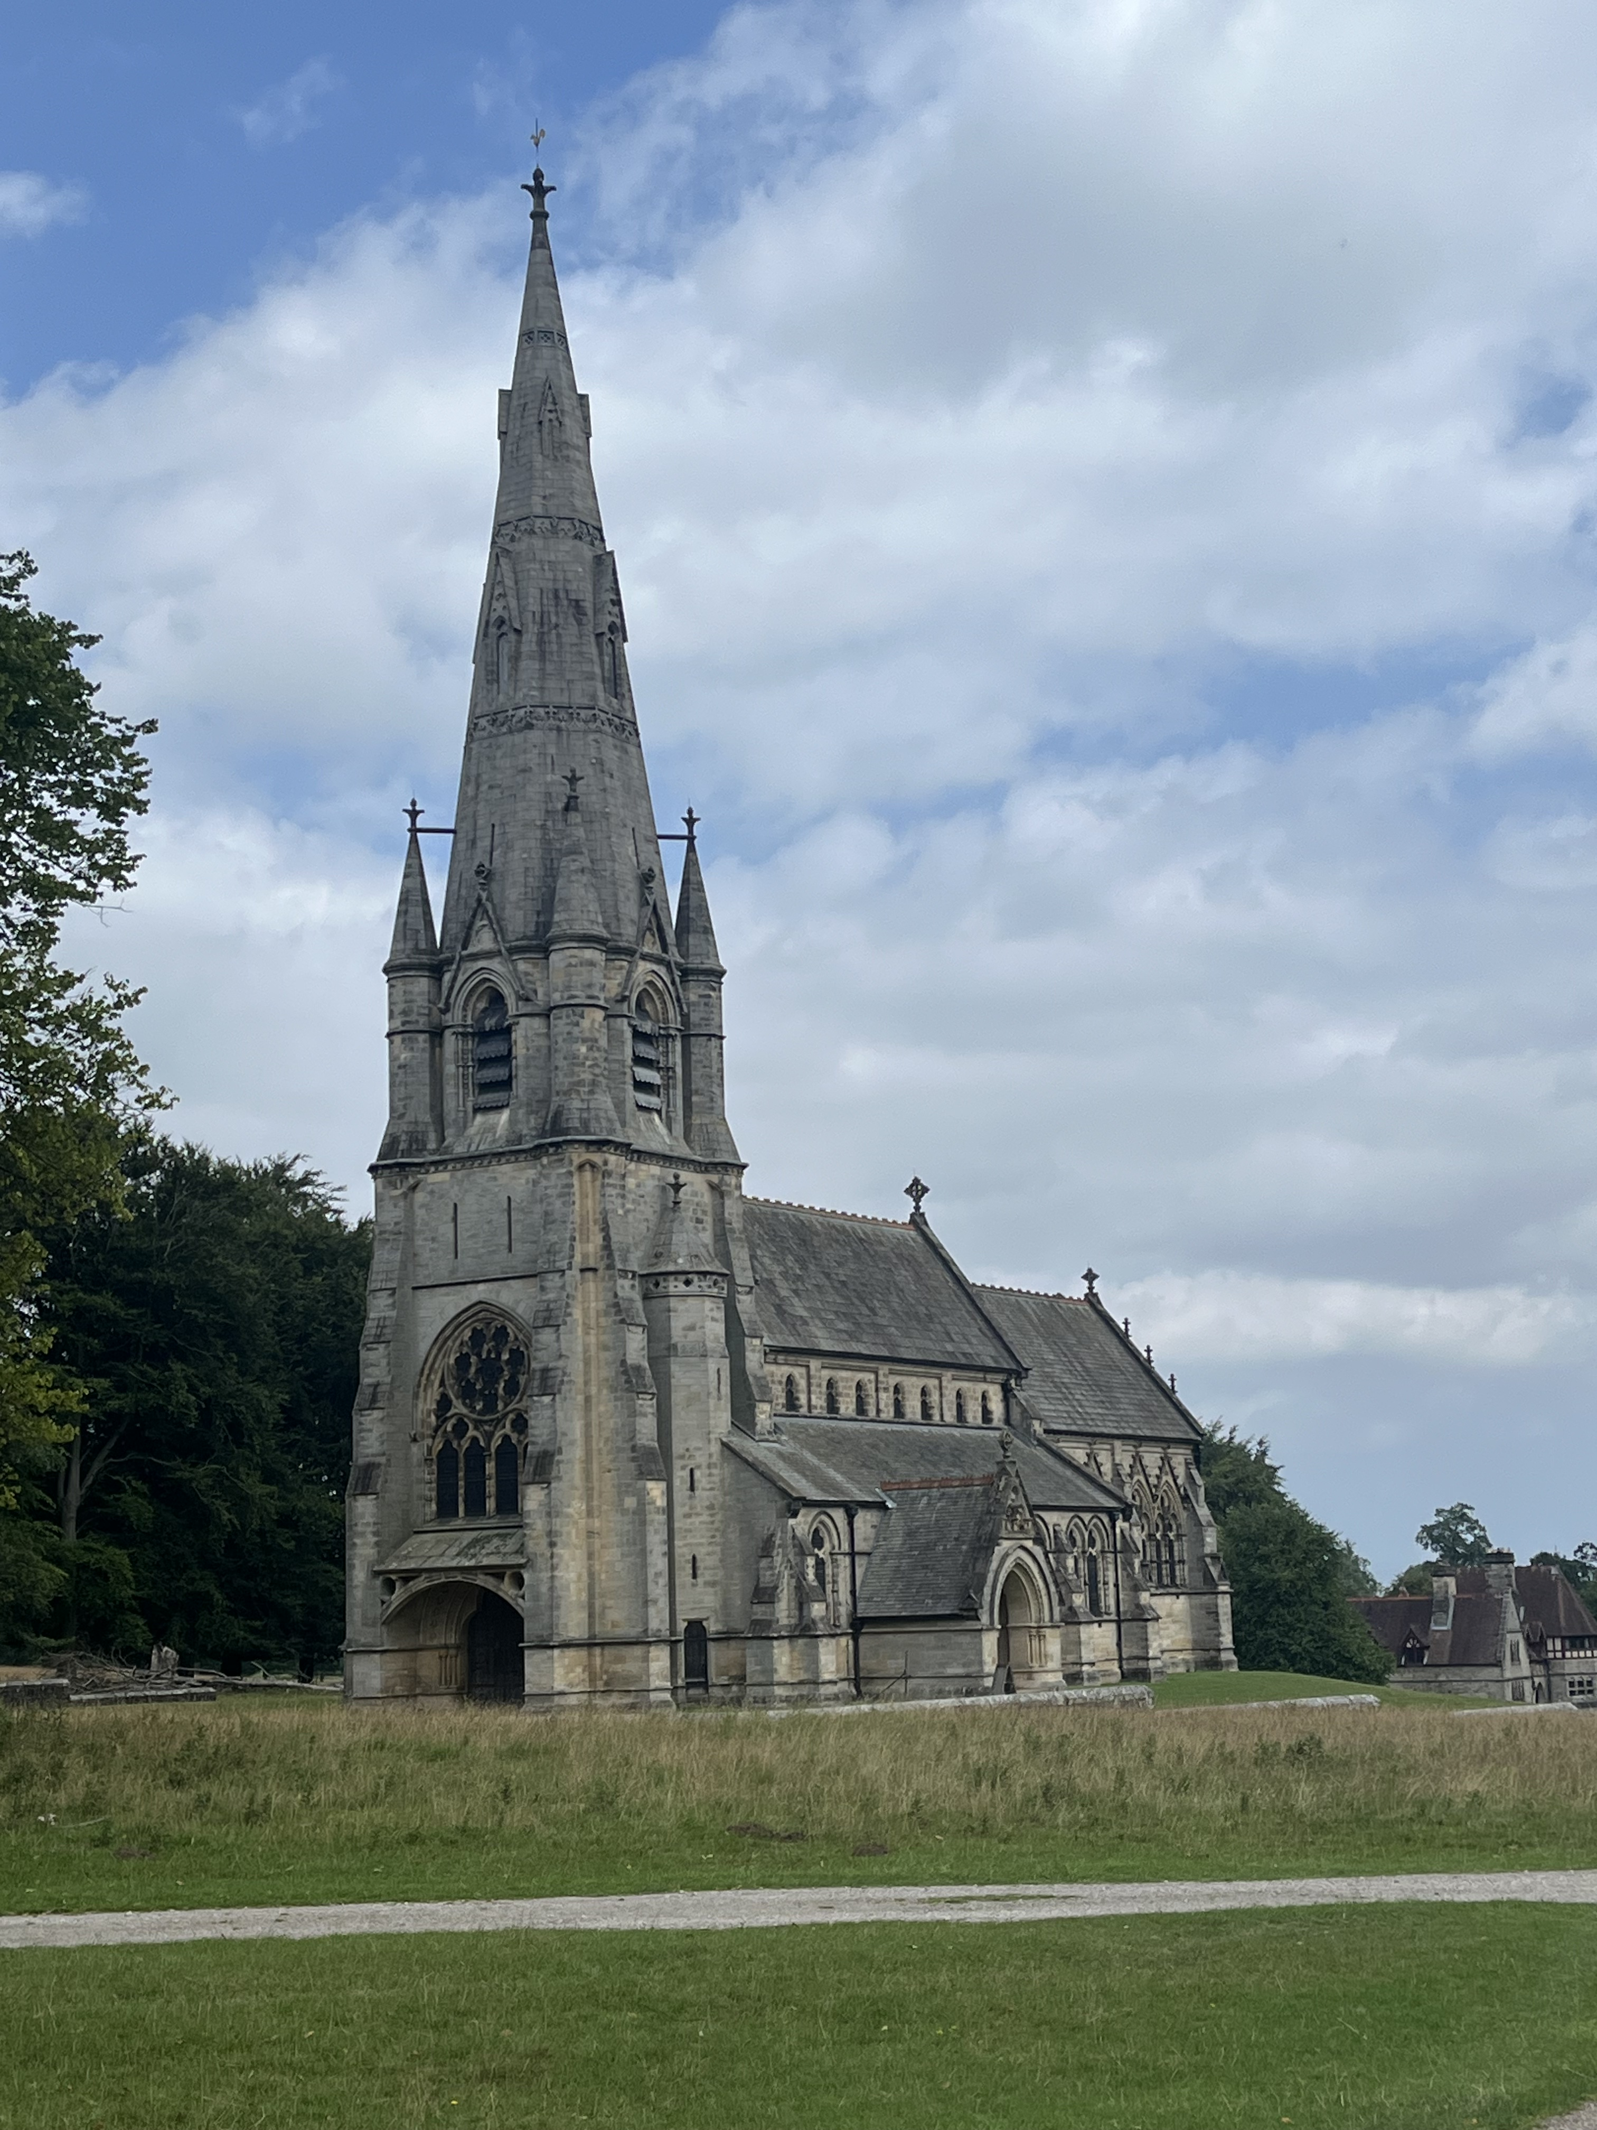Studley

Revd Andrew Cromarty, Associate Priest and Project Co-ordinator

