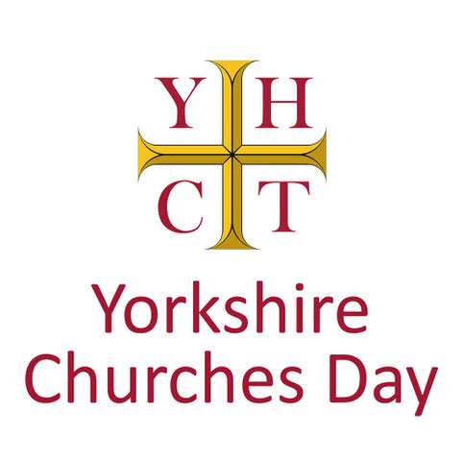
A more unusual highlight of Yorkshire Churches Day in 2025 will be a tour of churches associated with ‘Deserted Medieval Villages’ in East Yorkshire.

Wharram Percy is a nationally famous as one of the best excavated and studied ‘deserted’ or ‘shrunken’ medieval villages of England. Today, the ruins of the church survive as a reminder of this once-thriving settlement, surrounded by the earthwork remains of peasant tofts and crofts and manor houses which gradually disappeared over the centuries. Once thought to be a legacy of the Black Death, archaeological excavations and analysis over several decades has revealed a much richer and longer history of places like Wharram, and surrounding sites such as Cowlam and Cottam.

For Yorkshire churches day, our guide will be ‘landscape detective’ and Wharram expert, Dr Al Oswald, who will share his expert reflections on the site, starting at the church at 11am. Wharram Percy is accessed by foot from a car park signposted off the B1248. Parking is free for English Heritage members, £2 for non-members, payable by text or by visiting English Heritage’s visitor parking website: https://eh.tap2park.com/find.location.php.
The village is a ¾ of a mile walk down a steep slope. Although the church of St. Martin is a ruin, evidence of its evolution and contraction from the 12th to the 17th century is preserved in its standing fabric and has been revealed by excavation. This includes traces of the earliest, possibly 10th century timber church on the site and numerous burials and monuments revealing the osteoarchaeological evidence of former residents.

Returning uphill to the car park, we invite you to make your way either to Sledmere House with its café and toilet facilities for lunch, or the facilities of the Fimber Café, at the roundabout junction of the B1248 and B1251. From Fimber, we invite you to gather from 2pm at Cowlam church. Continue through Sledmere on the B1253 turning left to continue on the B1253 Bridlington road.

Cowlam church is a Grade II listed building which appears at first glance to be a complete rebuilding in 1852 for Sir Tatton Sykes. Yet inside this small building is an exquisite tub font with figures set within arcading. Looking beyond the church itself, it is clear that Cowlam is another shrunken former medieval settlement, with earthworks and farm buildings which have also intrigued archaeologists.
From Cowlam, it is also possible to walk to the lost village and derelict church of Cottam, whose font and door lintel now sit within the church at Langtoft. For those that don’t want to walk, to Cottam and back, you can drive to Langtoft from Cowlam, heading north back to the B1253 road. At the crossroads at the top turn right onto the B1253 and drive for just over a mile. Take the first turning right off the B1253 (sp Langtoft). Drive along that road for 2 miles (ignore the first left turning to Langtoft). At the second turning left to Langtoft, park your car on the wide verge and walk up the farm track to the right (sp footpath) which takes you to the site of Cottam deserted village and church in about 300 yards. You can walk round the site on a clearly defined path.

