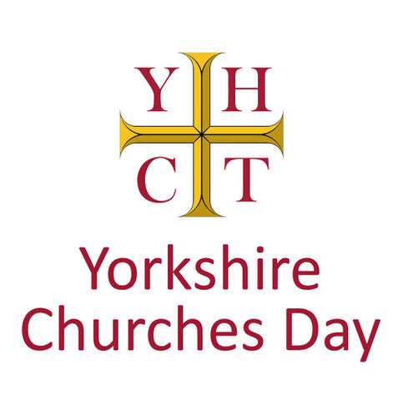
For Yorkshire Churches Day 2025, we are promoting some of the churches in the East Riding featured in the Sykes Churches (Northern Trail).

Sir Tatton Sykes, 5th baronet (1826-1913) of Sledmere succeeded to his 36,000 acre estate in the East Riding of Yorkshire in 1863. He continued the work of his father, the 4th baronet, who had begun to restore the churches of the Yorkshire Wolds. Between 1866 and his death in 1913, Tatton Sykes restored 17 rural churches, working with some of the leading church architects, including G.E. Street, Temple Moore and C. Hodgson Fowler and ecclesiastical artists of the day.

You can download a map of the churches here: https://www.eychurches.org.uk/index.php/our-leaflets/96-sykes-churches-trail-northern-route

We invite you to start at St. Andrew’s Weaverthorpe (YO17 8ES). Set high above the village alongside the earthworks of the medieval manor house is a beautiful Norman church restored for Tatton Sykes by G.E. Street. Highlights include a 12th century sundial over the entrance, decorated barrel vault roof and lavish Victorian furnishings, with stained glass by Clayton & Bell. Coffee and cake will be available in the morning, and the "golden gates" into the chancel will be opened up so visitors can see the chancel furnishings up close.

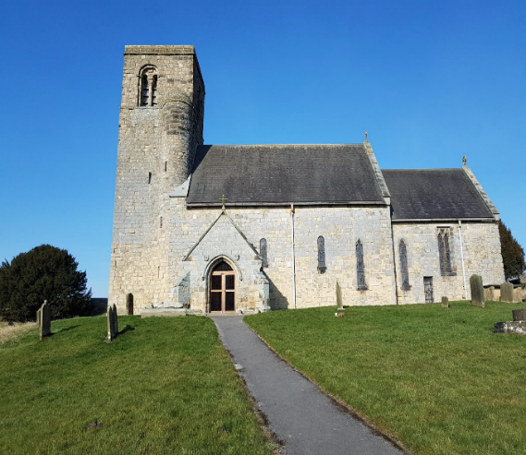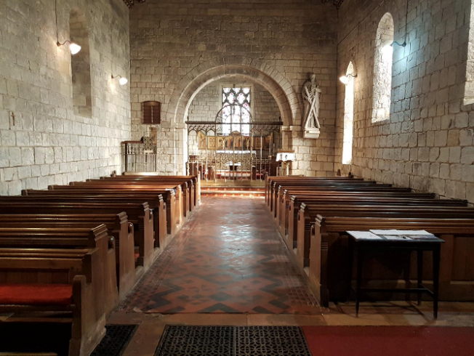
© Jane Crease - Weaverthorpe

Travelling west along the road at the foot of the dale takes you to St. Peter’s, Helperthorpe. This is another G.E. Street church built in 1871-3 in the Decorated style, with further additions by Temple Moore. The richly painted nave and chancel roofs are exquisite, as is the stained glass by Burlisson & Grylls. Please note, there is no access from the private drive to the vicarage; cars should be parked on the road in the village and visitors walk up through the farmyard (signed, with a right of access) to the church behind the farm.

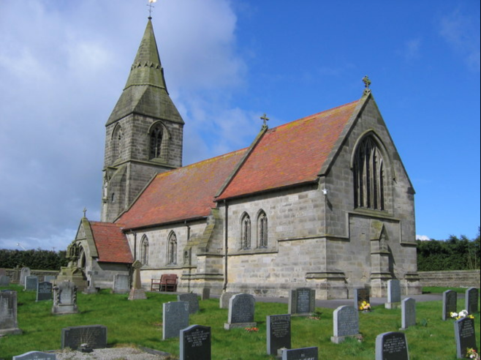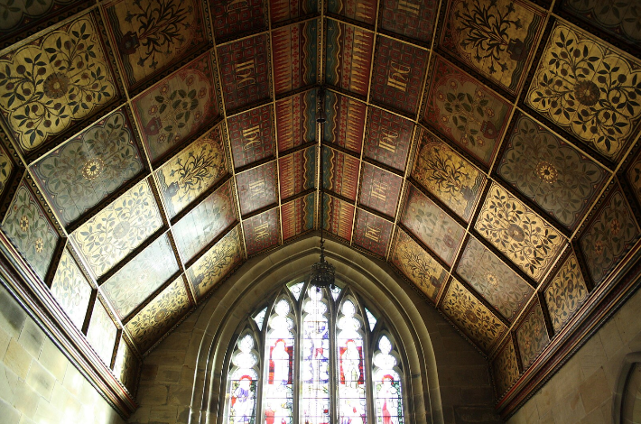
© Stephen Horncastle Helperthorpe © Nigel Coates Helperthorpe

Continue on to St Mary's, in West Lutton on the B1253. This church, like St Peter's in Helperthorpe is one of the finest examples of a Sykes church. Built in 1872-3 as one of the great series of 17 churches built or restored by Sir Tatton Sykes of Sledmere, designed by the great church architect G. E. Street with no expense spared, it is full of superb 19th century craftsmanship, from the painted roofs of the nave and aisles, the superb series of stained-glass windows (made in 1891 by Burlison and Grylls) to the ornately tiled floor, beautifully worked chancel gates and the reredos behind the altar.

It sits at the centre of the village and is still central to village life. Tea and coffee (plus home-made cakes) will be available on the morning of Yorkshire Churches Day on September 13th.

Parking opposite the church; a disabled toilet is in the church in the vestry.
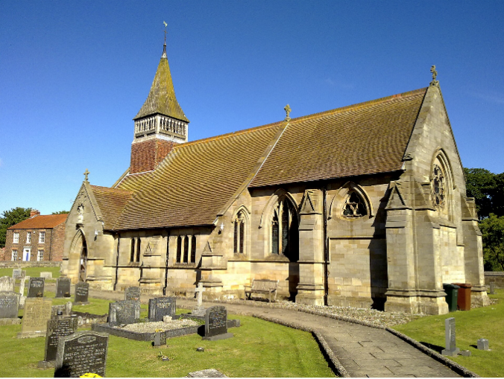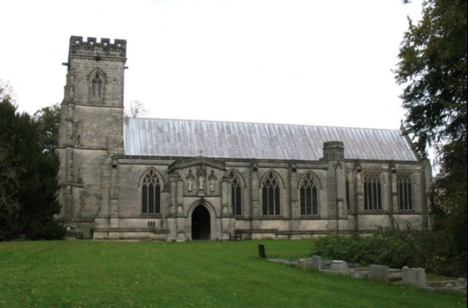
© Nigel Coates – West Lutton © Gordon Hatton- Sledmere

Why not take a break for lunch at Sledmere itself, where you can enjoy the largest and grandest of the Sykes churches built between 1893-8 by Temple Moore in the Decorated style on the site of an earlier 14th century church. The interior is richly carved with ornate wooden screen, rood loft and elaborate reredos, and Burlison and Grylls glass in the north aisle. Sledmere House has a wonderful café and toilet facilities, as well as the Waggoners’ Reserve Museum. Alternatively, take a picnic and enjoy the facilities of the Fimber Café, at the roundabout junction of the B1248 and B1251.

